**Core Components**

**Dependecies needed to leverage core components**

<dependency>

<groupId>com.adobe.cq</groupId>

<artifactId>core.wcm.components.all</artifactId>

<type>zip</type>

<version>2.3.2</version>

</dependency>

<dependency>

<groupId>com.adobe.cq</groupId>

<artifactId>core.wcm.components.examples</artifactId>

<type>zip</type>

<version>2.3.2</version>

</dependency>

**How to use core components:**

To the component created we add a property *sling:resourceSuperType*  pointing to a core component. This is nothing but creating proxy components.

|  |  |  |
| --- | --- | --- |
| **Core Component** | **Description** | **Replaced Foundation Component(s)** |
| [Page](https://adobe.com/go/aem_cmp_tech_page_v2) | Responsive page working with template editor | /libs/foundation/components/page /libs/wcm/foundation/components/page |
| [Breadcrumb](https://adobe.com/go/aem_cmp_tech_breadcrumb_v2) | Page hierarchy navigation | /libs/foundation/components/breadcrumb |
| [Title](https://adobe.com/go/aem_cmp_tech_title_v2) | H1-H6 title | /libs/foundation/components/title /libs/wcm/foundation/components/title |
| [Text](https://github.com/adobe/aem-core-wcm-components/tree/master/content/src/content/jcr_root/apps/core/wcm/components/text/v2/text) | Rich text | /libs/foundation/components/text /libs/foundation/components/table /libs/wcm/foundation/components/text |
| [Image](https://adobe.com/go/aem_cmp_tech_image_v2) | Smart and lazy loading of optimal rendition size | /libs/foundation/components/image /libs/foundation/components/adaptiveimage /libs/foundation/components/logo /libs/foundation/components/mobileimage /libs/foundation/components/mobilelogo /libs/wcm/foundation/components/image |
| [List](https://adobe.com/go/aem_cmp_tech_list_v2) | List of pages | /libs/foundation/components/list /libs/foundation/components/mobilelist /libs/wcm/foundation/components/list |
| [Social Media Sharing](https://adobe.com/go/aem_cmp_tech_sharing_v1) | Facebook and Pinterest sharing widget | - |
| [Form Container](https://adobe.com/go/aem_cmp_tech_form_container_v2) | Responsive form paragraph system | /libs/foundation/components/form/start /libs/foundation/components/form/end |
| [Form Text](https://adobe.com/go/aem_cmp_tech_form_text_v2) | Text input field | /libs/foundation/components/form/text /libs/foundation/components/form/password |
| [Form Options](https://adobe.com/go/aem_cmp_tech_form_options_v2) | Multiple options input field | /libs/foundation/components/form/checkbox /libs/foundation/components/form/radio /libs/foundation/components/form/dropdown |
| [Form Hidden](https://adobe.com/go/aem_cmp_tech_form_hidden_v2) | Hidden input field | /libs/foundation/components/form/hidden |
| [Form Button](https://adobe.com/go/aem_cmp_tech_form_button_v2) | Submit or custom button | /libs/foundation/components/form/submit |
| [Navigation](https://adobe.com/go/aem_cmp_tech_navigation_v1) | A site navigation component that lists the nested page hierarchy | /libs/foundation/components/topnav /libs/foundation/components/mobiletopnav |
| [Language Navigation](https://adobe.com/go/aem_cmp_tech_langnav_v1) | A language and country switcher that lists the global language structure | - |
| [Quick Search](https://adobe.com/go/aem_cmp_tech_search_v1) | A search component that displays the results as in-place suggestions in a drop-down menu | /libs/foundation/components/search |
| [Teaser](https://adobe.com/go/aem_cmp_tech_teaser_v1) | Allows the content author to easily create a teaser to further content using an image, title, or rich text and linking to further content or other actions | - |
| [Tabs](https://adobe.com/go/aem_cmp_tech_tabs_v1) | Allows the content author to organize page content within multiple tabs | - |
| [Carousel](https://adobe.com/go/aem_cmp_tech_carousel_v1) | Allows the content author to organize content in a rotating carousel of slides | /libs/foundation/components/carousel |
| [Content Fragment](https://adobe.com/go/aem_cmp_tech_cf_v1) | Allows for the display of a content fragment | - |
| [Content Fragment List](https://adobe.com/go/aem_cmp_tech_cflist_v1) | Allows for the display a list of content fragments | - |
| [Separator](https://adobe.com/go/aem_cmp_tech_separator_v1) | Separates content on a page | - |
| [Accordion](https://adobe.com/go/aem_cmp_tech_accordion_v1) | Organize content panels in a collapsible accordion | - |
| [Container](https://adobe.com/go/aem_cmp_tech_container_v1) | Organize components within a container | - |
| [Button](https://adobe.com/go/aem_cmp_tech_button_v1) | Create a button on a page | - |
| [Download](https://adobe.com/go/aem_cmp_tech_download_v1) | Add a downloadable asset to a page | - |
| [Experience Fragment](https://adobe.com/go/aem_cmp_tech_xf_v1) | Add an experience fragment to a page | /libs/cq/experience-fragments/editor/components/experiencefragment |
| [Embed](https://adobe.com/go/aem_cmp_tech_embed_v1) | Embed an external resource within a page | - |
| [Progress Bar](https://adobe.com/go/aem_cmp_tech_progress_v1) | Provide a visual representation of progress towards a goal | - |

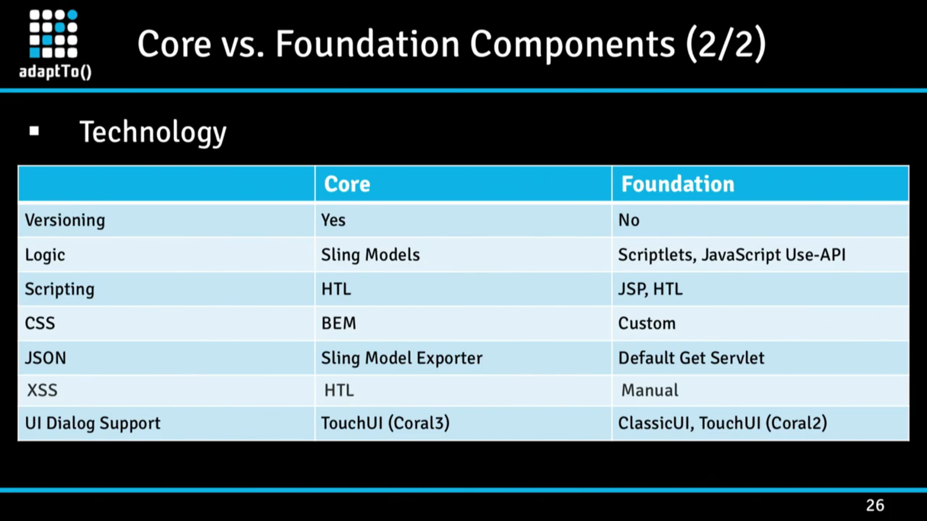

* The core components implement the style system. Means the template editor or the content author can create multiple variants of the component using various sets of css made available to them. Refer below

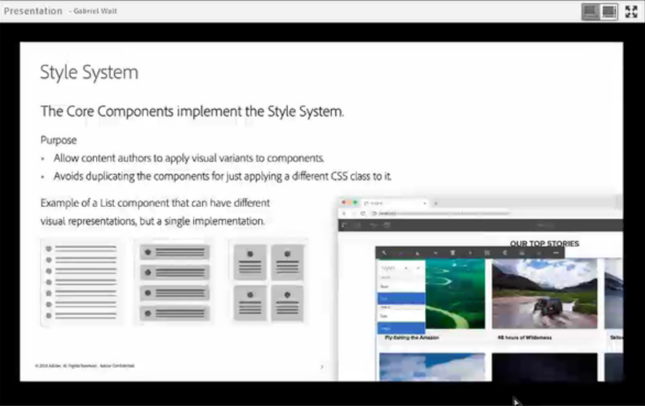

* The core components are backed by HTL(rendering) and sling Models(backend logic).To extend core components, all we need to do is create a dummy component (sling:resourceSuperType 🡪/core/wcm/components/v1/title). This is proxy component which inherits from Core component.
* To extend core component via proxy, we need to either customize HTL / dialog / sling Model
* All the sling model implementations for core components are at com.adobe.cq.wcm.core.components.models
* To extend Title component, we need a new sling model implementing com.adobe.cq.wcm.core.components.models.Title as below. 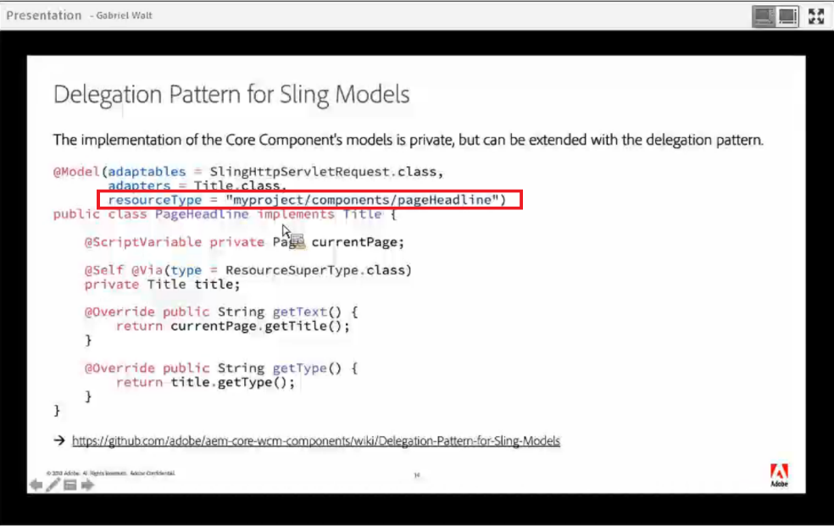
* Whenever a new implementation is made available to core components, the appropriate impl gets picked up based on resourceType. This should match the resourceType of our proxy component in the site

Useful Resources

<https://experienceleaguecommunities.adobe.com/t5/adobe-experience-manager/delegation-pattern-for-title-component-what-get-method-needs-an/qaq-p/322780>